
Presents

10 mile Summer Classic Time Trial incorporating the Essex TT Championships

Promoted for and on behalf of Cycling Time Trials under their Rules and Regulations

Saturday 29th July 2023
Course E91/10B - Start at 8:00

Event Headquarters: Leaden Roding Village Hall, Stortford Road, Leaden Roding, Essex, CM6 1QX. Open from 7:00

Event Organiser: Mr Paul Hart, Heath View, 32 Downham Road, Ramsden Heath, Essex, CM11 1PU
paul@hartperformancecoaching.com / 07528 681085

Timekeepers: Mr Trevor Pedley & Mr Ian Taylor

A HUGE thank you to our Event Sponsors





AWARDS

Junior Boy:
1st: £100 NoPinz Voucher, Turbo Towel & Other Goodies
2nd: £75 NoPinz Voucher & Turbo Towel
3rd: £50 NoPinz Voucher & Turbo Towel

Ladies TT:
1st: £100 NoPinz Voucher & Goodies
2nd: £75 NoPinz Voucher
3rd: £50 NoPinz Voucher

Mens TT:
1st: £100 NoPinz Voucher & Goodies
2nd: £75 NoPinz Voucher
3rd: £50 NoPinz Voucher

Ladies RB:
1st: £100 NoPinz Voucher & Goodies
2nd: £75 NoPinz Voucher
3rd: £50 NoPinz Voucher

Mens RB:
1st: £100 NoPinz Voucher & Goodies
2nd: £75 NoPinz Voucher
3rd: £50 NoPinz Voucher

Prize Presentation: 10:15am in the Village Hall. Please stay and either collect your prize or congratulate the award winners.

Champions to have photo taken with Champions Jersey during presentation.

At HQ there will be free Tea/Coffee and amazing cakes @ £1 each. Please bring change!

Course Code: E91/10B

START at give way sign in Lane from High Easter just before the Four Wantz crossroads at Margaret Roding. Turn left on A1060 towards Chelmsford.
TURN at Beddells End Roundabout (5.4miles) and retrace to FINISH at a point 392 yards past Peppers Green sign, opposite wooden post 15yards before signpost to ‘The Easters’

Course map
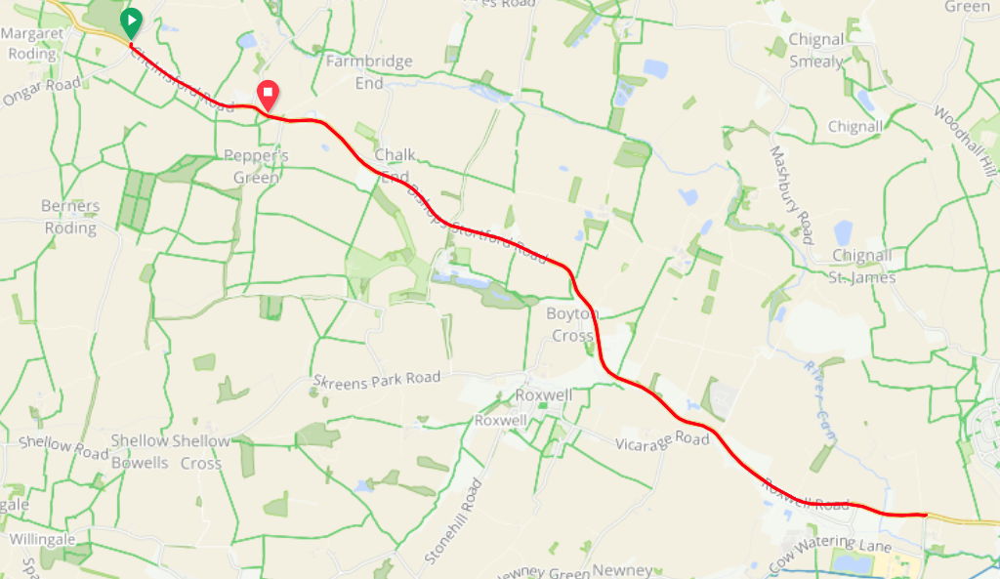

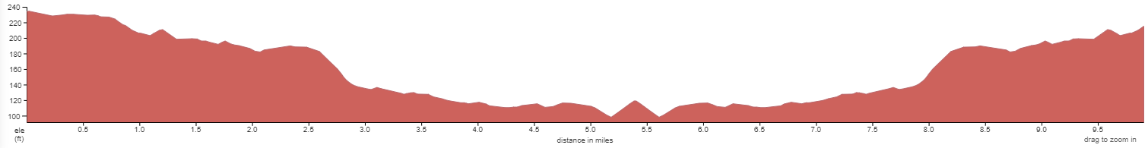

Strava: https://www.strava.com/segments/10246105?filter=overall

Course Records:
Ladies: Louise Robinson 23:32 (2022)
Mens: Alex Dowsett 19:06 (2010)
Junior: James Wicks 23:24 (2022)

Road Bike Records:
Ladies: Camilla Wilkes 26:51 (2022)
Mens: Jonny Allen 20:56 (2022)
Junior: Tom Womack 23:59 (2022)

HQ to start: 1.7 miles.
PLEASE ALLOW 10-15 MINS.
LEFT out of HQ to the mini roundabout. RIGHT onto the A1060 (Chelmsford Road).

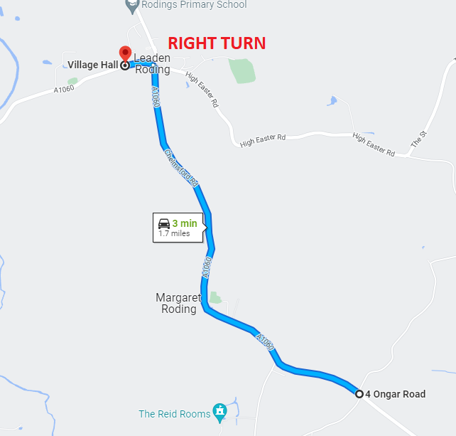

Reserve Course: We have the E91/10A booked as a reserve course in case of roadworks or any other unforeseen circumstance. This course runs from Aythrope Roding to Clapton Hall Lane and back.

Parking: The HQ has a generous car park including an overflow car park (on the field). Please park efficiently and considerately.

Additional Parking: If for some reason there isn’t enough room at HQ, there is a lay-by outside the Rodings Primary School in Leaden Roding (CM6 1PZ) which will accept approx. 30 cars. Please note no cars may park at the start or the finish, nor on the verges adjacent.

Sign In / Out. All competitors must sign in at HQ and collect their number. Once finish you must return your number to HQ and Sign out. If you do not sign out you will be DQ’d.

Lights: The use of FRONT and REAR lights whilst competing is MANDATORY. These lights must be switched on and working at the start of the event. No lights No ride.

Cycling helmets: Cycling Time Trials require ALL COMPETITORS wear a HARD-SHELL HELMET that meets an internationally accepted safety standard. No Helmet No ride.

Litter: Riders are reminded that dropping litter (such as energy gel wrappers) is a criminal offence and offenders will be liable to disciplinary action by the District Committee.

Warming up: In respect of consideration for local residents, the use of static trainers, e.g.. turbo trainers, is banned from all morning events held in the London East District. No warming up along the course by competitors once the event has started.

No ‘U’ Turns: are allowed within sight of either the start or finishing points. Riders carrying out this dangerous manoeuvre are liable for disqualification from the event and further disciplinary action by the District Committee.

Roundabout at mile 5.4: There is no prize for crashing. The roundabout is not the place to try and save 2 secs. Take your time, be aware of traffic. The road is not closed, there will be cars. You must follow the highway code.

Photographer: Paul Hughes will be taking photos of the event. These will be available free of charge to all. Please have a BIG smile if the camera comes near you. We aim to capture the friendly atmosphere of a typical local time trial to share with all those who did not enter (but hopefully will next time!)

Road Bike Prizes: There will be a marshal at the start who will check those who are riding road bikes are eligible. To clarify:
- No clip on TT bars
- No wheels over 90mm deep (including disc wheel)

Live Timing: TimeTrialHQ.com
TimeTrialHQ.com timing system run by Phil Hodey of the Shaftesbury Cycling Club will be in operation during the event. There will be a 2mtr screen in HQ displaying live results including split at the turn.
It’s an online system so can be accessed remotely. Feel free to share this link with your club/team facebook pages / whats app groups etc so those not at the event can still track the times.
https://results-board.web.app/KLqfLG1GQ6S4ZYU9NUEo

Essex Time Trial Championship

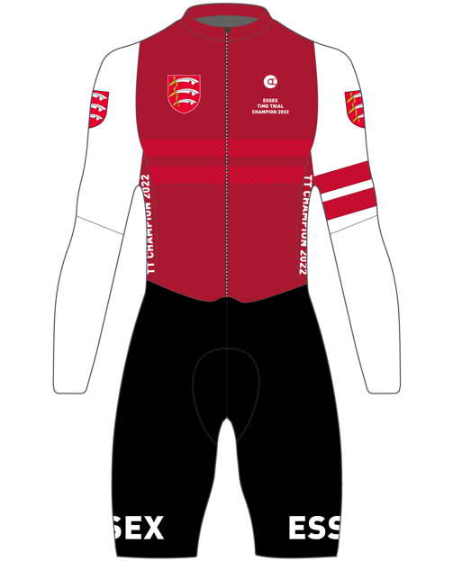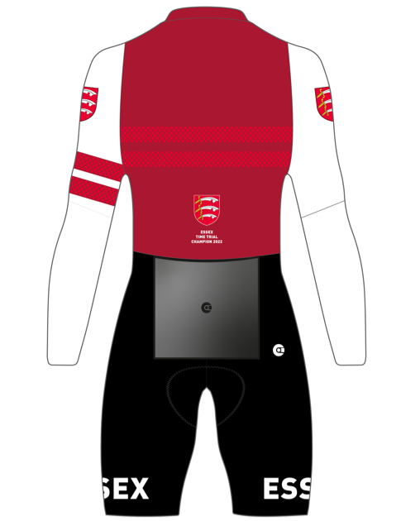

Champions Kit: NoPinz have designed an Essex Champions Skinsuit, Jersey, Shorts and Gilet. Skinsuit pictured above. These can be only ordered by the Champions. NoPinz have kindly donated vouchers as prizes to help with the purchases. CTT have approved the wearing of the Essex Champions kit at both club and open TT events.

Eligibility: Your registered address with CTT to be an Essex address. Those eligible for the Essex Championship listed below.

Note re kit usage: Only the current champions can wear the skinsuit in open time trials. If you lose the championship in 2023 you can no longer wear the skinsuit in open time trials. You can however wear the kit in club TT events or training for as many years as you wish.

Junior Champion: Fastest junior wins irrespective of road bike or TT bike.

- Junior Girl Essex TT Champion
- Junior Boy Essex TT Champion
- Ladies Essex TT Champion
- Men’s Essex TT Champion
- Ladies Essex Road Bike TT Champion
- Men’s Essex Road Bike TT Champion

Is this your first time trial?

We are delighted to have so many new time triallists at our event. Thank you to all of you that have entered. To help with that pre-race anxiety here are a few tips:

- Read the full start sheet. It will contain lots of important information.
- Aim to arrive at the HQ an hour before your start time. Being late increases stress. Park in the designated car park and you can change at the HQ.
- Sign on and collect your race number. Pin it down low on your back so it can be seen by the timekeepers. If you are under 18 you must have a signed parental form and hand it to the organiser or official when signing on.
- Ensure your bike is ready a few days before the event. You do not want to be making adjustments before the race. Its beneficial to be relaxed and calm before your race.
- Know how to get to the start. Maybe print a map. Also buddy up with someone in the car park who is starting at a similar time to you and ride to the start together. This will also help with pre-race nerves.
- Ensure you have your number pinned on, a working front and rear light and are wearing a helmet before you set off towards the start.
- The start is 1.7 miles from HQ. Use this ride as your warmup. Allow minimum 20-25 mins to relax and do a thorough warm up. Arrive at the start 5mins before your start time and wait. Remember No U turns in sight of the start or finish.
- Know the route. At 5.4 miles there is a small roundabout. Retrace that and ride back. Simple!
- Ride as fast (and safely) as you can. Take your time at the roundabout. That is not the place to try and save a few seconds. Be safe!
- If you see a photographer on the course, ensure you have a BIG smile!
- Once finished ride back to the HQ. Ensure you hand your race number back and sign out. To be featured in the results you must do this.
- When at the HQ have a cuppa and some cake and get your excuses ready for why you didn’t win!
- Start to plan how you will go faster next time.

HPC Partners





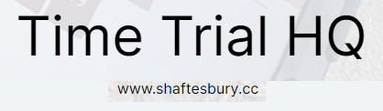
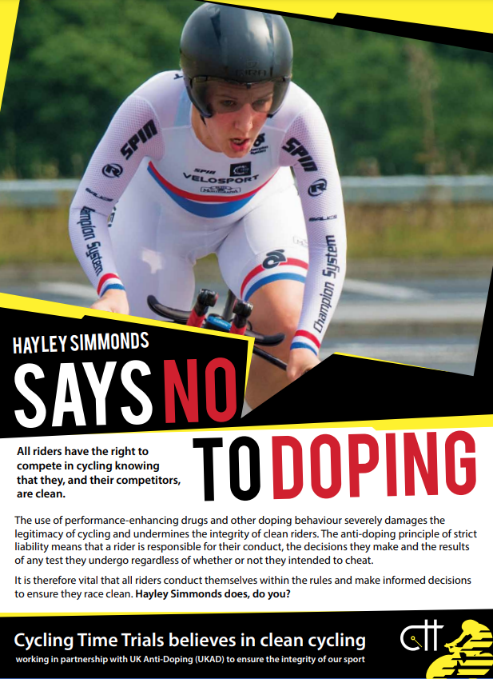

 |  | Start |  |  | Essex
 | No. | Time | Name | Club | Qualifying
Junior | 14 | 08:14 | Charles Langford | Southend Wheelers | Y
 | 15 | 08:15 | James Wicks | HPC | Y
 | 16 | 08:16 | Morgan Saunders | HPC | Y
Ladies TT | 19 | 08:19 | Courtney Granger | Athlon | Y
 | 20 | 08:20 | Claire Lee | Shaftesbury | Y
 | 21 | 08:21 | Rachel Halamandres | Basildon | Y
 | 22 | 08:22 | Jan Harvey | Southend Wheelers | Y
 | 23 | 08:23 | Camilla Wilkes | HPC | Y
 | 24 | 08:24 | Lauren Harding | Chelmer | Y
 | 25 | 08:25 | Karen Aylen | Maldon | Y
 | 26 | 08:26 | Louise Robinson | ERCC | Y
Mens TT | 29 | 08:29 | Edward Perry | Southend | Y
 | 30 | 08:30 | Johnnny Garrett | Clapham Chasers | N
 | 31 | 08:31 | James Bromley | HPC | Y
 | 32 | 08:32 | Anthony Whale | Blue Light CC | Y
 | 33 | 08:33 | Ian Damant | Becontree | Y
 | 34 | 08:34 | Colin Doe | Ford | Y
 | 35 | 08:35 | Philip Hodey | Shaftesbury | Y
 | 36 | 08:36 | Chris Smith | ERCC | Y
 | 37 | 08:37 | Andrew Merchant | Southend | Y
 | 38 | 08:38 | Jonathan Whitwam | Shaftesbury | Y
 | 39 | 08:39 | Graham Hurrell | Basildon | Y
 | 40 | 08:40 | Simon Ginger | Shaftesbury | N
 | 41 | 08:41 | Harry Moore | Hackney | N
 | 42 | 08:42 | Paul Gribbon | Southend | Y
 | 43 | 08:43 | Mark Lloyd | Colchester | Y
 | 44 | 08:44 | Adrian Tovey | Maldon | Y
 | 45 | 08:45 | Andrew Whelan | Velo Schills | Y
 | 46 | 08:46 | Tom Bishop | Walden Velo | Y
 | 47 | 08:47 | Peter Tibbitts | Ford | N
 | 48 | 08:48 | Stephen Murphy | Shaftesbury | Y
 | 49 | 08:49 | Neal Marrin | Finsbury | N
 | 50 | 08:50 | Michael Beaver | Athlon | Y
 | 51 | 08:51 | Peter Robertson | Lea Valley | N
 | 52 | 08:52 | Andy Grant | Chelmer | Y
 | 53 | 08:53 | Dominic Shills | Velo Schills | Y
 | 54 | 08:54 | Joe Kerner | TrainSharp | Y
 | 55 | 08:55 | Luca Morrone | Onyx | N
 | 56 | 08:56 | Dan Jenkins | HPC | Y
 | 57 | 08:57 | Paul Turton | Team Vision | Y
 | 58 | 08:58 | Henry O'Kill | Southend | Y
 | 59 | 08:59 | Matt Steel | Pronto | Y
 | 60 | 09:00 | Lee Turner | Arctic Aircon | N
 | 61 | 09:01 | Alfie Salmon | HPC | N
 | 62 | 09:02 | Simon Alexander | Richardsons Trek | Y
 | 63 | 09:03 | Samuel Thienel | Elysium Kalas RT | Y
 | 64 | 09:04 | Timothy Torrie | Trainsharp | Y
 | 65 | 09:05 | Alex Dowsett | NoPinz | Y
Ladies RB | 67 | 09:07 | Caroline Wyke | Sudbury | Y
 | 68 | 09:08 | Ruth Stapleton | Harlow | Y
 | 69 | 09:09 | Paulina Mozal | Chelmer | Y
Mens RB | 72 | 09:12 | Jacobus Van Der Poel | Harlow | Y
 | 73 | 09:13 | Kevin Coombes | Harlow | Y
 | 74 | 09:14 | Iona Luca | Harlow | N
 | 75 | 09:15 | Richard Elven | Harlow | Y
 | 76 | 09:16 | Toby Hetherington | Harlow | Y
 | 77 | 09:17 | Josh Winch | Harlow | Y
 | 78 | 09:18 | Ben Spurgeon | Harlow | Y
 | 79 | 09:19 | Slawomir Puklo | Harlow | Y
 | 80 | 09:20 | Tim Simpkins | Harlow | Y
 | 81 | 09:21 | Jamie Bishop | Harlow | Y
 | 82 | 09:22 | Adam Ashwell | Harlow | Y
 | 83 | 09:23 | Stephen Hitchcock | Sudbury | Y
 | 84 | 09:24 | Marc Brant | Southend | Y
 | 85 | 09:25 | John Paduano | Southend | Y
 | 86 | 09:26 | Phillip Brant | Southend | Y
 | 87 | 09:27 | Patrick Claridge | Chelmer | Y
 | 88 | 09:28 | Adam Jones | Southend | Y
 | 89 | 09:29 | Alex Eason | Chelmer | Y
 | 90 | 09:30 | Paul Donegan | Chelmer | Y
 | 91 | 09:31 | Tony Meader | Eagle | N
 | 92 | 09:32 | Michael Stimson | Maillot Noir | Y
 | 93 | 09:33 | Nick Boyle | Chelmer | Y
 | 94 | 09:34 | Jon Wileman | HPC | N
 | 95 | 09:35 | Stuart Clarke | Chelmer | Y
 | 96 | 09:36 | Louis Digance | HPC | Y
 | 97 | 09:37 | Matthew Saward | Athlon | Y
 | 98 | 09:38 | Colin Ward | ERCC | Y
 | 99 | 09:39 | Aaron Green | Shaftesbury | Y
 | 100 | 09:40 | Paul Hart | HPC | Y

